Coding assignment TNO:PPAM:
English
Write a program that computes a trajectory for a projectile. The projectile is assumed to be a perfect sphere with a radius of 3 cm, and a density of 7.8 g/cm³. The projectile is launched at an 45 degree angle from at X=Y=0 with an initial velocity of 200 m/s.
For this calculation we take into account gravity (9.81 m/s²) and drag. The drag should be computed using the following formula, where ρ is the density (in kg/m³) and A the frontal area. The drag coefficient C_{D} can be assumed to be 0.47. The drag always points opposite to the projectile’s velocity.
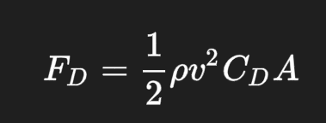
For the numerical integration you can use Forward Euler integration. However, try to structure your code such that the integration method is easy to exchange if we like to use another method. This holds for the velocity and launch angle as well, which might be subject to change.
Because we neglect any side forces, this can be reduced to a 2D problem where Z is always 0. At what time and distance will the projectile hit the ground again?

For a second computation, we’d like to add a thrust of 100N for the first 5 seconds. Assume that the thrust continues to work in the 45 degree angle (same as the original launch angle). At what time and distance will the projectile hit the ground again now?

Programming Languages:
Preferred C# or Python, but any language may be used.
Bonus:
Change the method of numerical integration to a Simplectic Euler integration (Explicit Time Integration - Physics-Based Simulation).
Plot the trajectory traveled in a 2D plot.
More bonus points can be scored by sharing your solution via Git.

